Programming an AudioLux One

1. Download and instal Arduino Software IDE
   1. <https://www.arduino.cc/en/Main/Software>  
      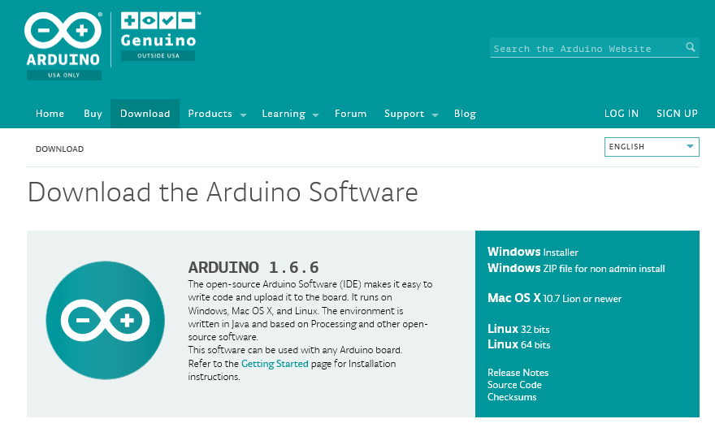
2. Download and install FastLed Library
   1. <https://github.com/FastLED/FastLED/releases>  
      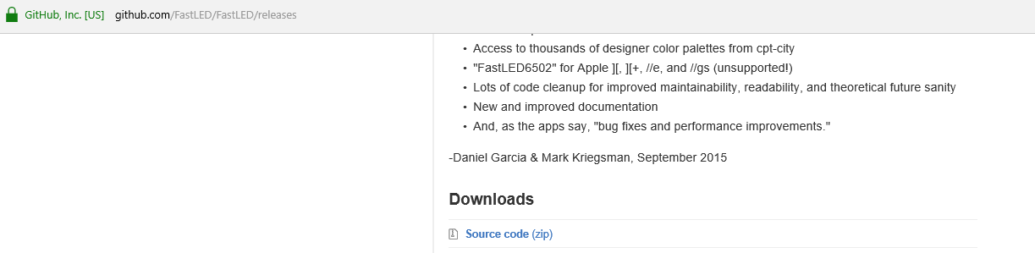
   2. Guide to installing Libraries  
      https://www.arduino.cc/en/Guide/Libraries
3. Download Audiolux program (Sketch) from GitHub
   1. <https://github.com/CymaSpace/Programs---Sketches/tree/master/Neal%20Wright/A4>
4. Plug in AudioLux with USB A to B cable (i.e. printer cable)
5. Open Arduino Software IDE
6. Open Up AudioLux Sketch  
   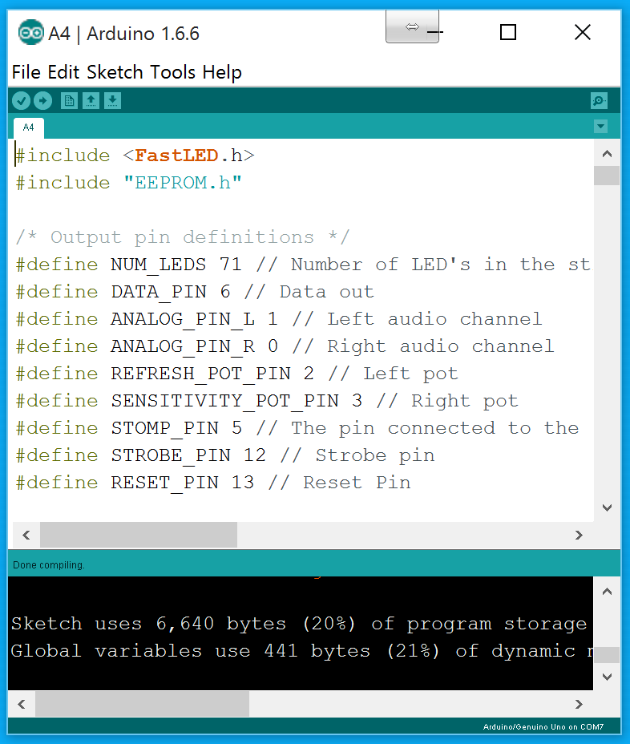
7. In “Tools” then “Port” Select the serial port of the connected Audiolux.
8. Click Upload (A button that has an arrow pointing to the right on the top left of the Arduino Software)